|  |  |  |
| --- | --- | --- |
| Product Name | Battery connector |  |
| Connector Type | Battery base |  |
| Applicable Battery Specifications | CR1220 |  |
| Operating Temperature Range | - |  |

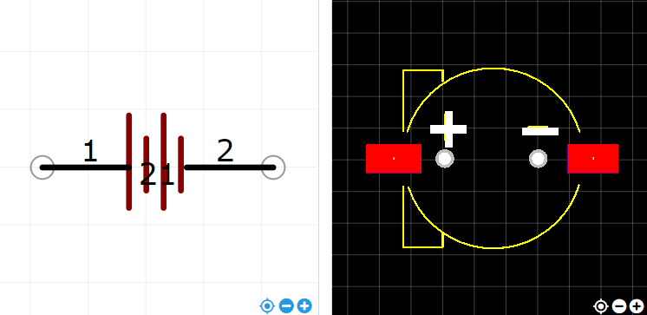

<https://item.szlcsc.com/71476.html>s